**Sort Questions and Answers**

Q.1 What is Routing and on which OSI layer it happens?

Q.2 Write any two advantages of static routing.

Q.3 What happens when default routing is applied in networks other than stub networks?

Q.4 What DCE & DTE stand for?

Q.5 What OSPF stands for and what is its Metric/Cost?

Q.6 What is the difference between subnet mask and wildcard mask?

Q.7 Differentiate Distance Vector and Link State routing protocols.

Q.8 Write one example each of Distance Vector and Link State.

Q.9 Why is ACL and its Types?

Q.10 Where we can apply ACL?

**Step no: 1.** Use 187.200.1.0/24 address and perform subletting first.

Perform OSPF and submit screenshots of all the steps and outputs.

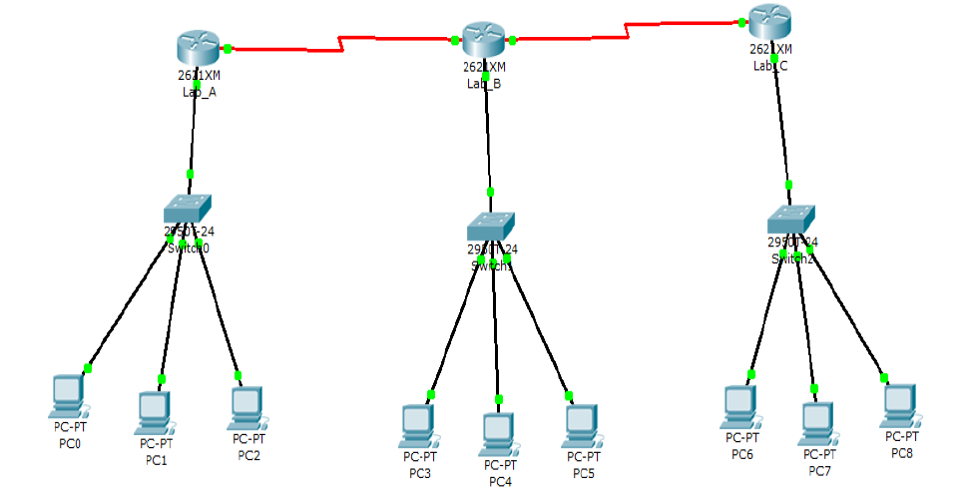

**Step no: 02**. Perform ACL

1. Lab A only wants to communicate with Lab C.
2. Lab C only wants to accept traffic/communicate with PC3 in the Lab B.